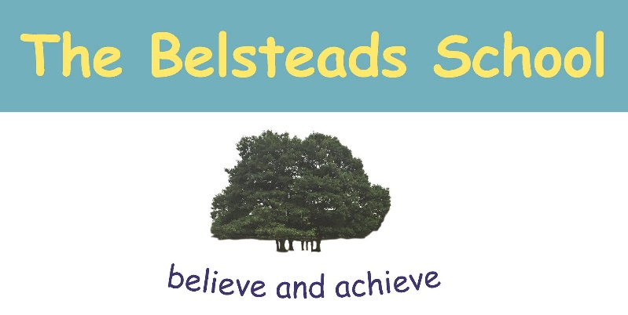

The Belsteads School Curriculum Policy

Version | 2
Name of Responsible (ratifying) Committee | Peter Adams – Chair of Governors  Signed:
Date Ratified | 11.12.19
Date Issued | 13.12.19
Review Date | Ongoing
Electronic Location | T Drive - Policies

The Curriculum
Intent
At The Belsteads School we want all of our pupils to believe in their right to grow and flourish in a nurturing learning environment. We want all of our pupils to achieve a strong sense of self-worth and resilience to be able to access their chosen life pathway.
We support pupils with this by asking them to engage in our Belsteads Pathways which inform our curriculum and are:
- Accreditation
- Careers and Employability
- Identity and Aspirations
- Community and Culture
- Resilience and Independence
- Health and Wellbeing

Through the Pathways, we aim to:
- facilitate the development of our pupils as a whole person and as responsible citizens with a positive sense of self
- Ensure our pupils become confident individuals who are able to live safe, healthy and fulfilling lives
- prepare our pupils for adulthood, including independent living and employment wherever possible

Implementation
Our curriculum is organised into separate subject areas through key stage 3 and 4. Based on the National Curriculum, it has been streamlined and supplemented based on the needs of our pupils. We aim to ensure that our curriculum is broad, balanced and focusses on functionality. We want it to be flexible enough to meet the needs of the diverse population within the school and matched to the individual needs of the pupil.
Impact
The effectiveness of our curriculum is measured by the pupils’ progress towards clearly defined outcomes of The Belsteads Pathways.

Curriculum Organisation
At The Belsteads School we give particular emphasis in our curriculum to the development of:
- Communication and Interaction Skills
- Cognition and Learning Skills, including Literacy, Numeracy and ICT skills
- Social, Emotional and Mental Health skills including PSHE, RSE (Relationship and Sex Education), Future Pathways and LOTC
- Sensory and Physical skills including PE and LOTC
- Work related and Vocational skills including Arts Award and community visits
Guided by the Pathways and maximising opportunities for links, real-world experience and learning, leaders and staff have reviewed our curriculum across key stage 3 and 4 to ensure it is well mapped and meets the needs of different cohorts of pupils. The lesson weighting is shown below:
 | Lessons | English | Maths | STEM | Comp | Hums | PSHE | LOTC | RSE | PE | Art | FP
Yr 7 | 26 | 4 | 4 | 2 | 2 | 1 | 1 | 4 | 1 | 3 | 3 | 1
Yr 8 | 26 | 4 | 4 | 2 | 2 | 1 | 1 | 4 | 1 | 3 | 3 | 1
Yr 9 | 26 | 4 | 4 | 2 | 2 | 1 | 1 | 4 | 1 | 3 | 3 | 1
Yr 10 | 26 | 4 | 4 | 2 | 2 | 1 | 1 | 4 | 1 | 3 | 3 | 1
Yr 11 | 26 | 4 | 4 | 2 | 2 | 1 | 1 | 4 | 1 | 3 | 3 | 1

As pupils move through the school, increasing emphasis is placed on preparation for adulthood and maximising independence. Where relevant, opportunities are provided for pupils to participate in mini-enterprise activities, community visits linked to specific career pathways and planning for transition to post-16 to prepare them for life after school.
Personalised Learning
We adapt the curriculum for individual learners according to their needs. We recognise pupils’ strengths, needs and interests and build on these to promote achievement and success. We identify our pupils’ needs through the Annual Review process and plan and adapt provision and learning opportunities to meet these needs.
We are committed to providing the best learning opportunities, including access to community resources and learning programmes that link classroom learning to life skills.
All children learn best from first hand experience. To develop a full understanding of a concept a child must have relevant, practical learning experiences in different situations. We strive to provide opportunities to practice and apply learning in many contexts.

Planning
In planning the curriculum and putting this policy into practice, The Belsteads School aims to ensure that:
- Lessons are challenging and have pace, rigour and direction for each of the pupils
- A range of relevant teaching styles are employed to ensure that we meet pupil’s individual needs
- On-going assessment informs planning
- Children’s learning progresses smoothly through the school and prepares them, for life beyond school
It is the role of all staff within the school, through implementing this policy and other school policies and practices, to ensure that they provide a variety of relevant experiences for children in the classroom that serve to develop knowledge, skills and understanding and enable children to value themselves as learners.
Assessment, record keeping and Accreditation
Pupils are screened for reading and spelling ages at in Dec and June of the academic year using online, standardised New Group Spelling Test (NGST) and New Group Reading Test (NGRT). In the Spring term each pupil will also sit a (CAT) cognitive ability test (CAT) and a online PASS screening (Pupil attitudes to self and school) which provides us with valuable data to enable us to identify fragile learners and their potential barriers to learning.
Due the vertical groupings of the pupils, the curriculum model uses a series of ‘I can’ statements that reflect skills ranging from Early Learning Goals through Entry Level and culminating in skills needed for Functional Skills and GCSE accreditation (see Assessment Policy). Each ‘I can’ statement is also mapped to The Belsteads Pathways (Appendix 1) which enables us to identify gaps in wider skills that our pupils will need to access the wider world around them when they leave school.
Learning in KS4 is accredited in the following subjects:
- English
- Maths
- Arts Award
Our aim is for 100% of pupils to leave school with a formal English and maths qualification (Appendix 2).
Across the school, Arbor is used to record pupils’ working levels and progress made, using the ‘I can’ assessment frameworks for each subject cross linked with the Pathways.
Curriculum leads are responsible for reviewing the overall progress and achievements of pupils and for maintaining pupil data in a timely manner.
Pupil progress is reported to parents on a number of occasions during the school year. Written information is sent to parents as part of the Annual Review process. An end of year report and assessments are sent to parents in July. Parents are welcome to discuss their child’s progress at any other time during the year.
Monitoring
Monitoring procedures are in place through the LABS panel (learning, attendance, behaviour and safeguarding panel) which meets weekly and is made up of the headteacher, deputy headteacher and the curriculum leads. There is also feedback to Governors on developments in the curriculum on a half termly basis.

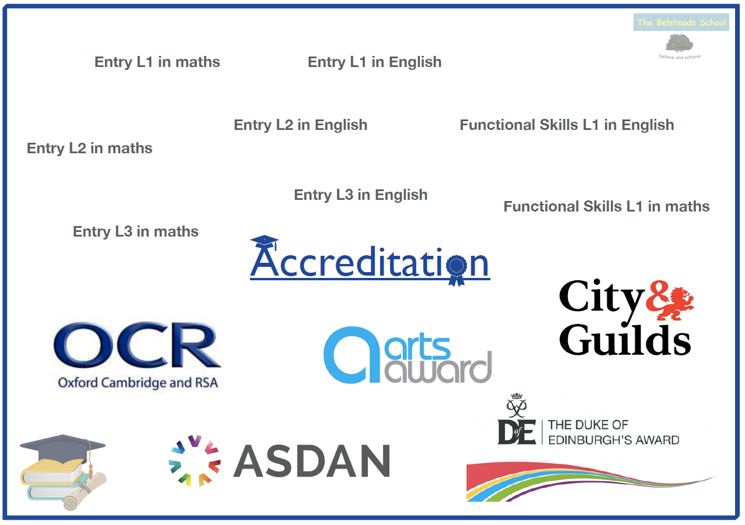
Appendix 1
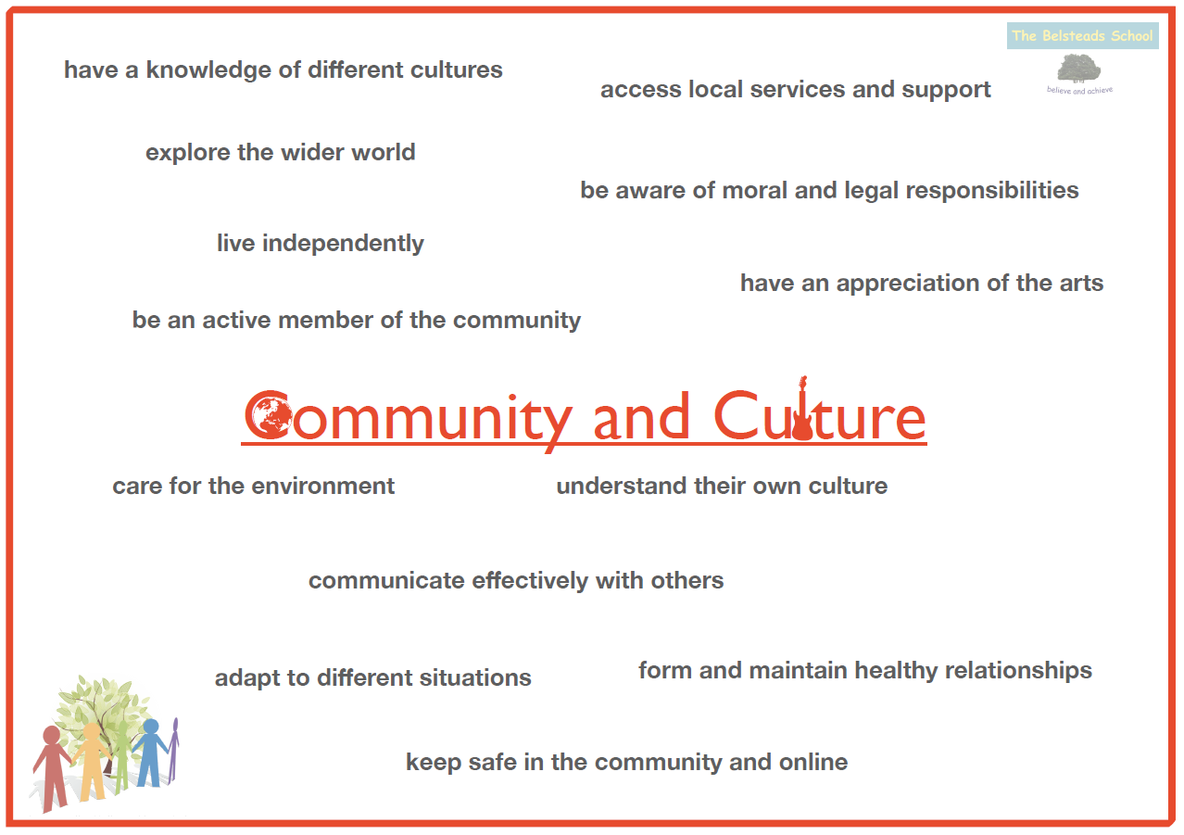
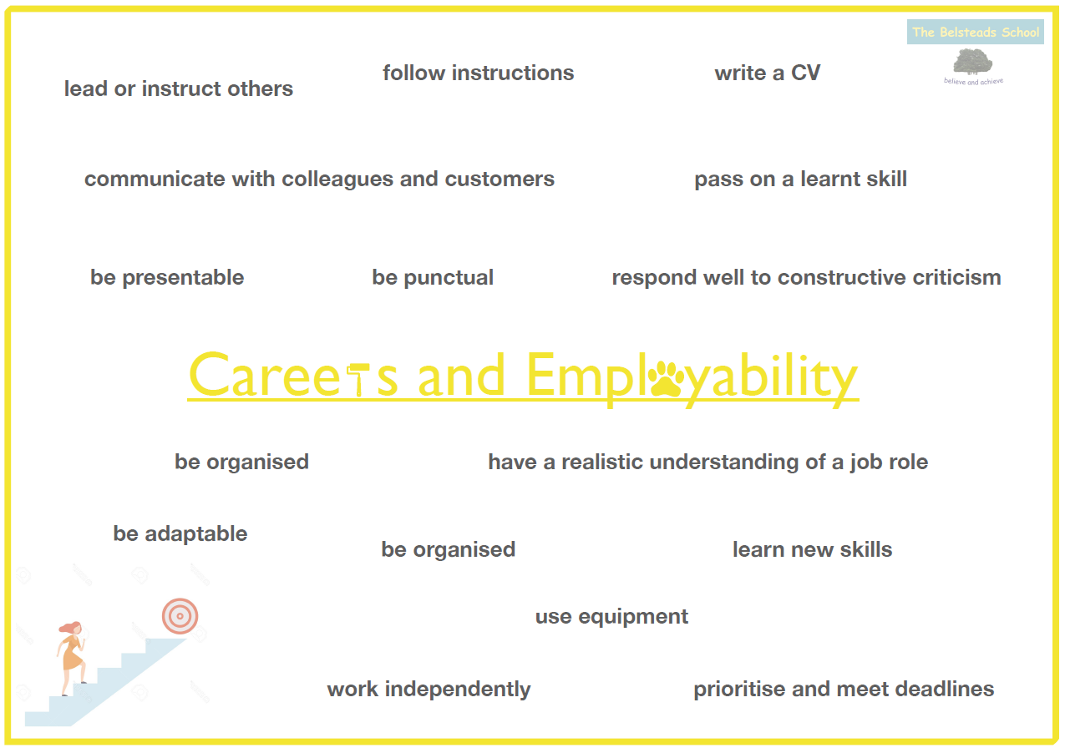
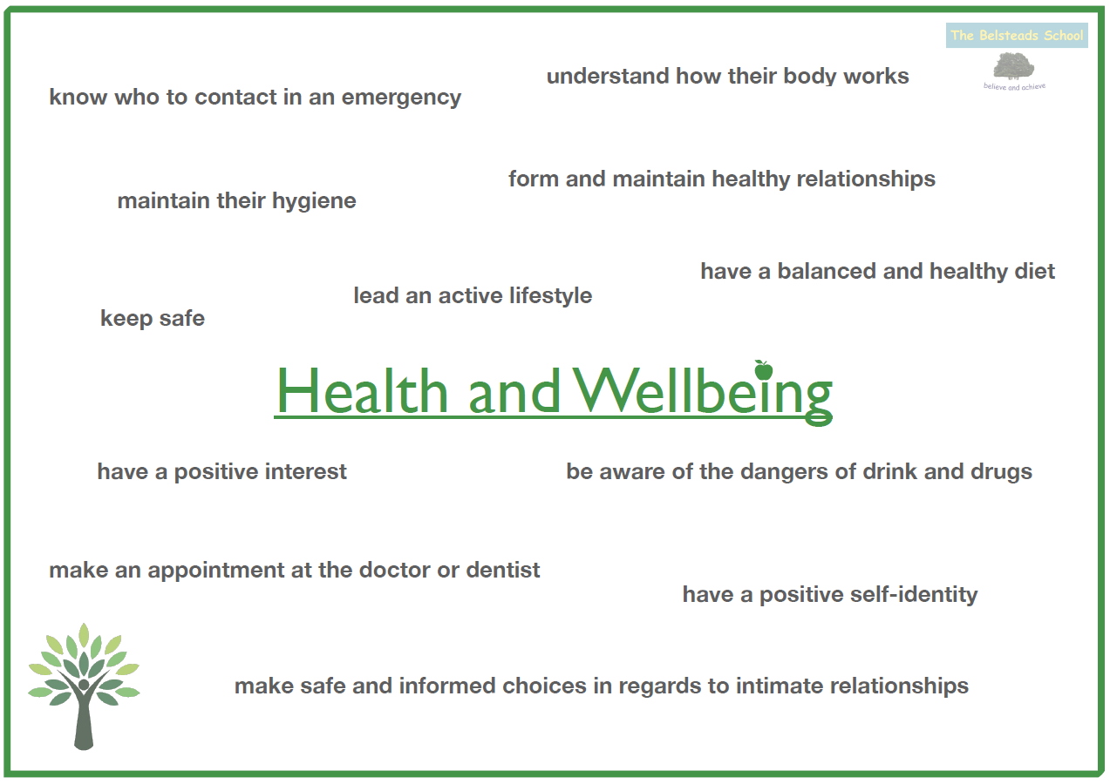
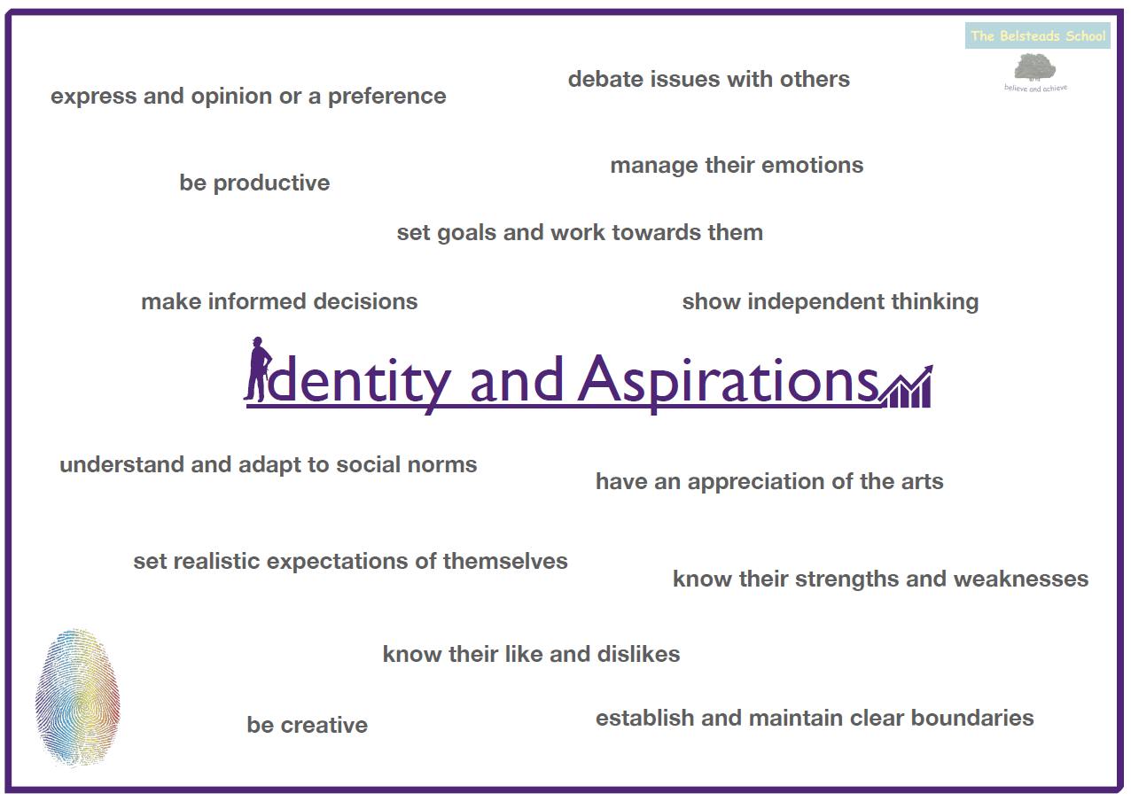
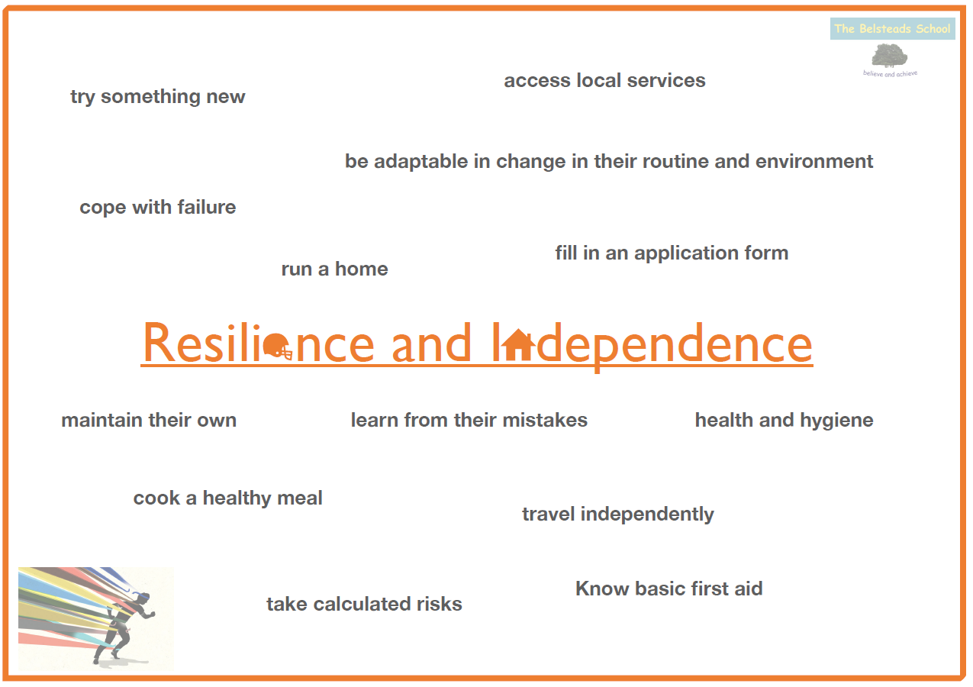
Appendix 2
Accreditation Pathway at The Belsteads School
Key Stage 4 pupils work towards the Accreditation Pathway. This suite of qualifications allow the achievements of all our pupils to be recognised and built upon. Pupils can make linear progress, moving up the levels in English, maths and Arts Award
Key Stage 4
Key Stage 3
Arts Award
Discover
Arts Award
Silver
Arts Award
Bronze
Functional Skills L2 qualification in English and/or maths
Foundation GCSE
in maths
Functional Skills L1 qualification in English and/or maths
Entry Level 1/2
Certificate in English and/or maths
13 – 14 credits
Entry Level 3
Certificate in English and/or maths
13 – 14 credits

