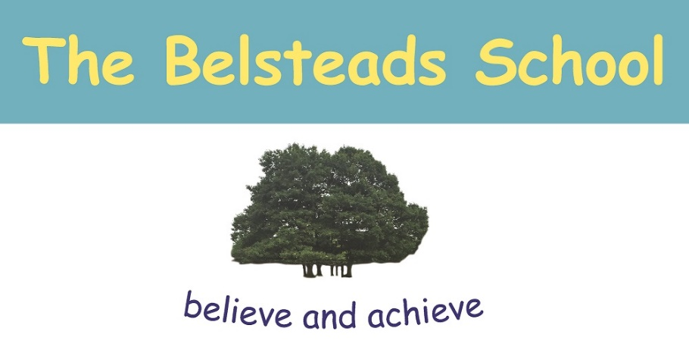

The Belsteads School Social Media Policy

Version | 1
Name of Responsible Person | Peter Adams – Chair of Governors
Date Ratified | 11th December 2019
Date Issued | January 2020
Review Date | 11th December 2020
Electronic Location | T Drive - Policies

Introduction to the Policy
The school is aware and acknowledges that increasing numbers of adults and children are using social networking sites. Some with the widest use are Instagram, Facebook and Twitter.
The widespread availability and use of social networking application bring opportunities to understand, engage and communicate with audiences in new ways.

It is important that we are able to use these technologies and services effectively and flexibly. However, it is also important to ensure that we balance this with our reputation.

This policy and associated guidance is to protect staff and advise school leadership on how to deal with potential inappropriate use of social networking sites.

For example, our use of social networking applications has implications for our duty to safeguard children, young people and vulnerable adults.

The policy requirements in this document aim to provide this balance to support innovation whilst providing a framework of good practice.

Purpose

The purpose of this policy is to ensure:
- That the school is not exposed to legal risks
- That the reputation of the school is not adversely affected
- That our users are able to clearly distinguish where information provided via social networking applications is legitimately representative of the school.

Scope

This policy covers the use of social networking applications by all school stakeholders, including, employees, Governors and pupils. These groups are referred to collectively as ‘school representatives’ for brevity.

The requirements of this policy apply to all uses of social networking applications which are used for any school related purpose and regardless of whether the school representatives are contributing in an official capacity to social networking applications provided by external organisations.

Social networking applications include, but are not limited to:
- Blogs, for example Blogger
- Online discussion forums, such as netmums.com
- Collaborative spaces, such as Facebook
- Media sharing services, for example YouTube
- ‘Micro-blogging’ applications, for example Twitter

All school representatives should bear in mind that information they share through social networking applications, even if they are on private spaces, are still subject to copyright, data protection and Freedom of Information legislation, the Safeguarding Vulnerable Groups Act 2006 and other legislation.

Use of Social networking sites in worktime

Use of social networking applications in work time for personal use only is not permitted, unless permission has been given by the Headteacher.
Social Networking as part of school service

All proposals for using social networking applications as part of a school service (whether they are hosted by the school or by a third party) must be approved by the headteacher or a member of the SLT first.

Use of social networking applications which are not related to any school services (for example, contributing to a wiki provided by a professional association) does not need to be approved by the headteacher. However, school representatives must still operate in line with the requirements set out within the policy.

School representatives must adhere to the following Terms of Use. The Terms of Use below apply to all uses of social networking applications by all school representatives. This includes, but is not limited to, public facing applications such as open discussion forums and internally-facing uses such as project blogs regardless of whether they are hosted on school network or not.

Where applications allow the posting of messages online, users must be mindful thatthe right to freedom of expression attaches only to lawful conduct. The Belsteads School expects that users of social networking applications will always exercise the right of freedom of expression with due consideration for the rights of others and strictly in accordance with these Terms of Use.

Terms of Use

Social Networking applications:

- Must not be used to publish any content which may result in actions for defamation, discrimination, breaches of copyright, data protection or other claim for damages. This includes but is not limited to material of an illegal, sexual or offensive nature that may bring the school into disrepute.
- Must not be used for the promotion of personal financial interests, commercial ventures or personal campaigns
- Must not be used in an abusive or hateful manner
- Must not be used for actions that would put school representatives in breach of school codes of conduct or policies relating to staff.
- Must not breach the school’s misconduct, equal opportunities or bullying and harassment policies
- Must not be used to discuss or advise any matters relating to school matters, staff, pupils or parents
- No staff member should have a pupil or former pupil under the age of 18 as a ‘friend’ to share information with
- Employees should not identify themselves as a representative of the school
- References should not be made to any staff member, pupil, parent or school activity / event unless prior permission has been obtained and agreed with the headteacher
- Staff should be aware that if their out-of-work activity causes potential embarrassment for the employer or detrimentally effects the employer’s reputation then the employer is entitled to take disciplinary action.

Violation of this policy will be considered as gross misconduct and can result in disciplinary action being taken against the employee up to and including termination of employment.

Guidance/protection for staff on using social networking

- No member of staff should interact with any pupil in the school on social networking sites
- No member of staff should interact with any ex-pupil in the school on social networking sites who is under the age of 18
- This means that no member of the school staff should request access to a pupil’s area on the social networking site. Neither should they permit the pupil access to the staff members’ area e.g. by accepting them as a friend.
- Where family and friends have pupils in school and there are legitimate family links, please inform the headteacher in writing. However, it would not be appropriate to network during the working day on school equipment
- It is illegal for an adult to network, giving their age and status as a child
- If you have any evidence of pupils or adults using social networking sites in the working day, please contact the named Child Protection person in school

Guidance/protection for Pupils on using social networking

- No pupil under 13 should be accessing social networking sites. This is the guidance from Facebook. There is a mechanism on Facebook where pupils can be reported via the Help screen; at the time of time of writing this policy the direct link for this is: http://www.facebook.com/help/contact.php?show_form=underage
- No pupil may access social networking sites during the school working day
- All pupil mobile phones must be handed into the office at the beginning of the school day
- No pupil should attempt to join a staff member’s areas on networking sites. If pupils attempt to do this, the member of staff is to inform the headteacher. Parents will be informed if this happens
- No school computers are to be used to access social networking sites at any time of day unless for direct school use (posting school information of the school Facebook page.)
- Any attempts to breach firewalls will result in a ban from using school ICT equipment other than with close supervision
- Please report any improper contact or cyber bullying to the class teacher in confidence as soon as it happens.
- We have a zero tolerance to cyber bullying

Child protection guidance

If the headteacher receives a disclosure that an adult employed by the school is using a social networking site in an inappropriate manner as detailed above they should:

- Record the disclosure in line with their child protection policy
- Schools must refer the matter to the LADO who will investigate
- If the disclosure has come from a parent, take normal steps to calm the parent and explain processes
- If disclosure comes from a member of staff, try to maintain confidentiality
- The LADO will advise whether the member of staff should be suspended pending investigation after contact with the police. It is not recommended that action is taken until advice has been given
- If disclosure is from a child, follow your normal process in your child protection policy until the police investigation has been carried out

Cyber Bullying

By adopting the recommended no use of social networking sites on school premises, The Belsteads School protects themselves from accusations of complicity in any cyber bullying through the provision of access.

Parents should be clearly aware of the school’s policy of access to social networking sites.

Where a disclosure of bullying is made, schools now have the duty to investigate and protect, even where the bullying originates outside the school.

